[Loai: NGHE – NGHE ĐỀ 1]

[Q]

**Part 4**

Directions: You will hear some talks given by a single speaker. You will be asked to answer three questions about what the speaker says in each talk. Select the best response to each question and mark the letter (A), (B), (C), or (D) on your answer sheet. The talks will not be printed in your test book and will be spoken only one time.

**Questions 29-31 refer to the following talk**

29-Where most likely does the talk take place?

1.In an office

0.In a laboratory

0.In a store

0.In a factory

[Q]

30-What does the speaker say about the Dayton facility?

0.An explosion was reported there.

0.Several people have been hired there.

1.People have been sent there to look at the problems.

0.It is going to close in the near future.

[Q]

31-What does the speaker tell the listeners to do?

0.Start finishing their work more quickly

0.Work more closely with their supervisors

1.Report problems when they see them

0.Show up for work earlier than normal

**Questions 32-34 refer to the following telephone message**

[Q]

32-What does the speaker ask Mr.Russell to do?

0.Make a payment

0.Call her back

0.Give some feedback

1.Visit the store

[Q]

33-What time will Winston’s open tomorrow?

0.At 8:00 A.M.

0.At 8:30 A.M.

1.At 9:00 A.M.

0.At 9:30 A.M.

[Q]

34-According to the speaker, how was the problem solved?

0.By installing a new speaker

1.By putting some software back onto the computer

0.By cleaning the computer thoroughly

0.By replacing the computer’s hard drive

**Questions 35-37 refer to the following telephone message**

[Q]

35-According to the speaker, what will happen on Wednesday?

0.A career fair

0.A promotional sale

0.A work site inspection

1.An employee orientation

[Q]

36-What does the speaker imply when she says, “I don’t have any appointment tomorrow?

0.She has not been successful with a client.

0.She thinks a schedule is wrong.

1.She has time to take over a task.

0. She needs to leave work early.

[Q]

37-What does the speaker ask the listener to do?

1.Call her back

0.Check a calendar

0.Reserve a booth

0.Cancel an event

[Q]

**Questions 38-40 refer to the following talk and map**

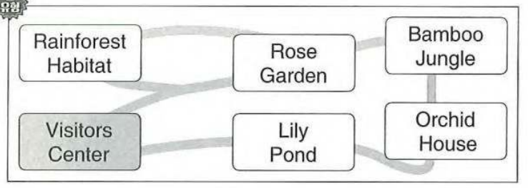

38-Why was the tour delayed?

0.A road was damaged.

0.A guide was late.

1.A vehicle was malfunctioning.

0.An attraction was closed.

[Q]

39-Look at the graphic. Which area will the group not be able to visit?

1.Rainforest Habitat

0.Rose Garden

0.Bamboo Jungle

0.Lily Pond

[Q]

40-What will the listeners receive at the visitors center?

0.A map

0.A brochure

0.A schedule

1.A free gift